Overview:
##### Request New Activationcode Page
Here you have a form with two input fields: CustomerNumber and Captcha.

CustomerNumber

* ```201000000``` The activation code was successfully requested
* ```422000000``` CustomerNumber is invalid.
* ```400000000``` Invalid Json response (response is html)
* ```400000001``` CustomerNumber is valid but wrong type. So he cannot request a new activation code.
* ```400000002``` The Activation code was already requested before and is over 5 days old. So here he can request a new one.
* ```400000003``` The activation code was already requested before and is under 5 days old. So here he have to wait.
* ```400000004``` The activation code was already requested several times. The limit is reached and he cannot request the activation code
* ```500000000``` HTTP response status code is 500

Captcha

Enter ```captcha```. Any other input will fail the validation.

What we did:
setup docker container in portals project

In EAP :
run npm ci
npm run build
npm run start-with-mock

Case 1: 201000000``` The activation code was successfully requested

1. Land on start page

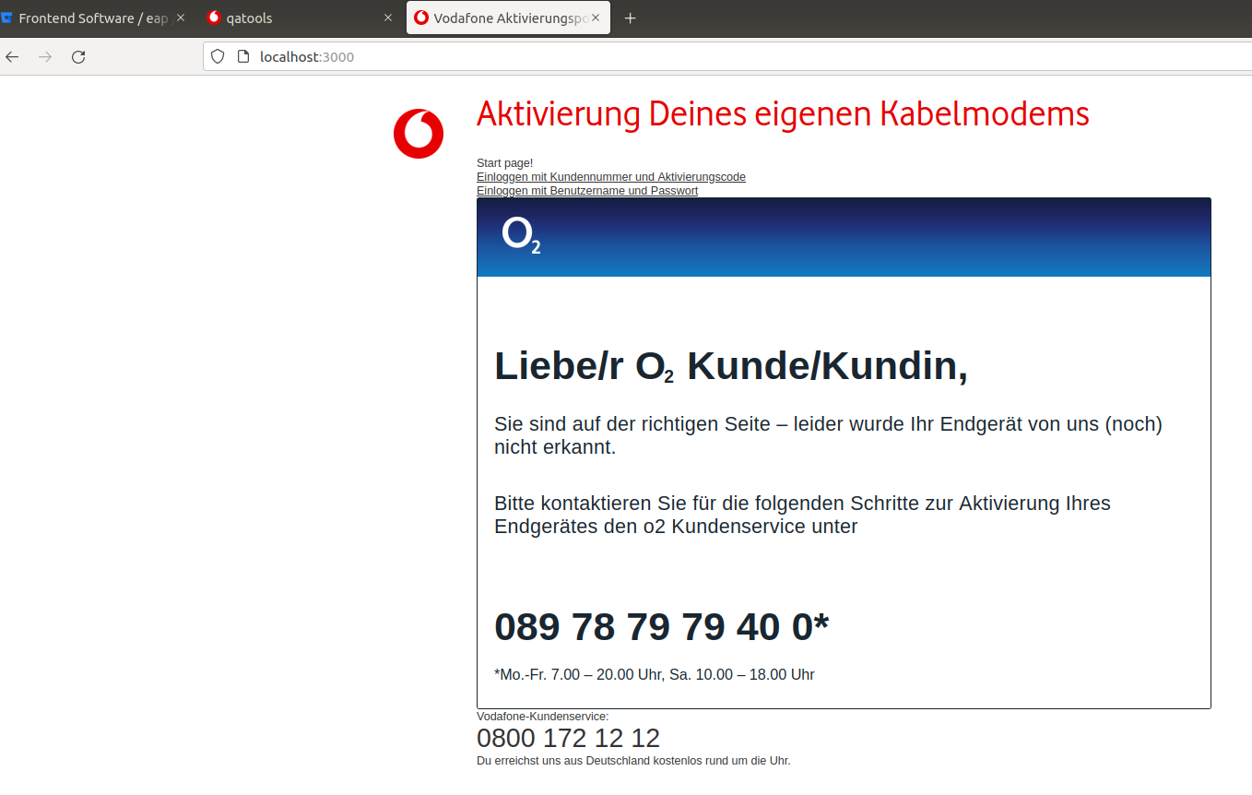

2. Click on Einloggen mit Kundennummer und Aktivierungscode
3. It should redirect to the activation page
4. Click on Dann fordere ihn jetzt an. To generate the new activation code
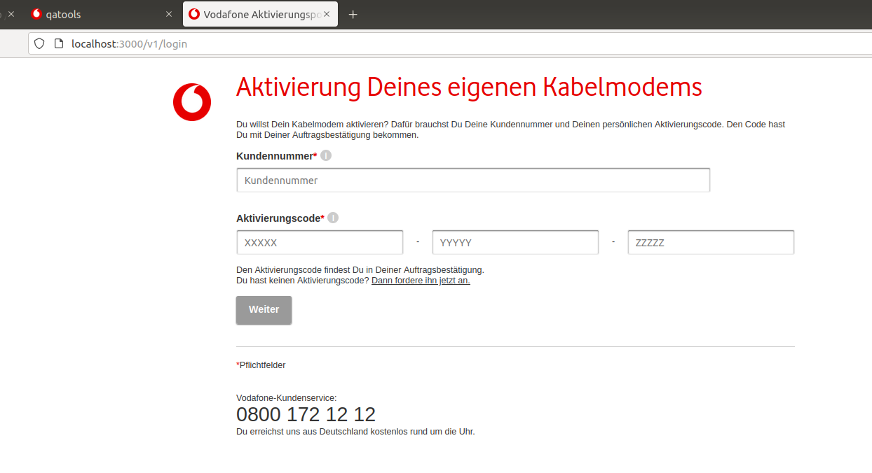

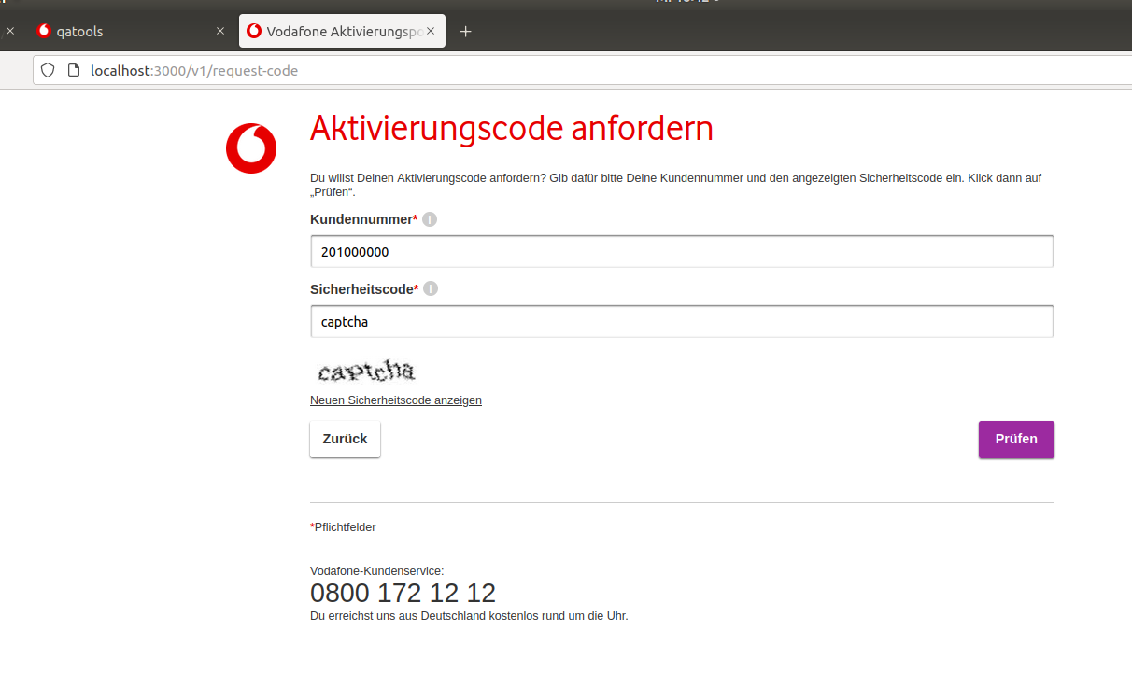

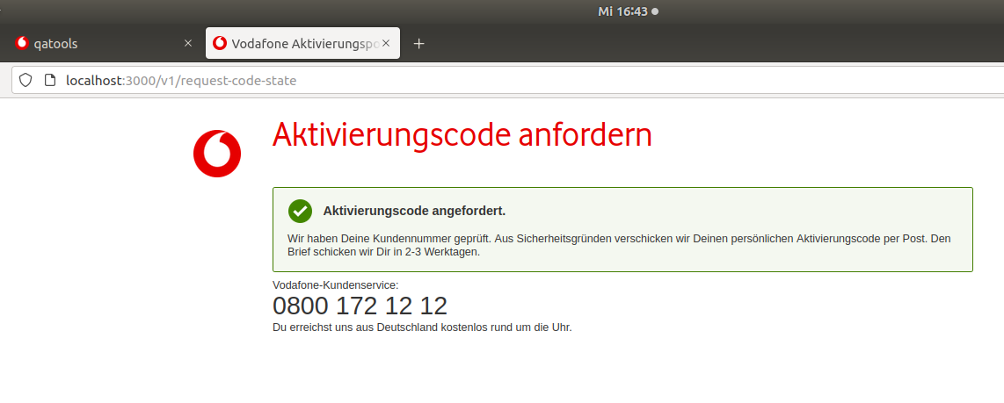
Case 2 :422000000` CustomerNumber is invalid.

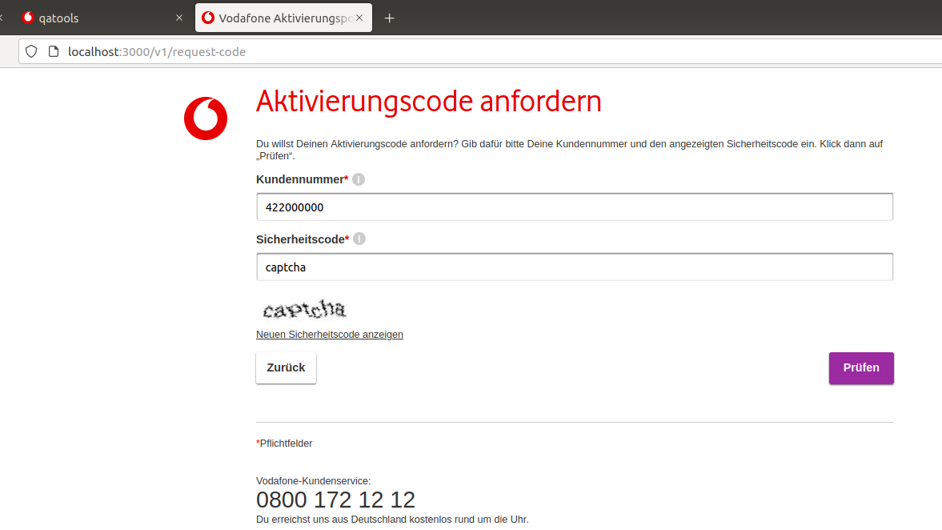

Received Invalid customer error :
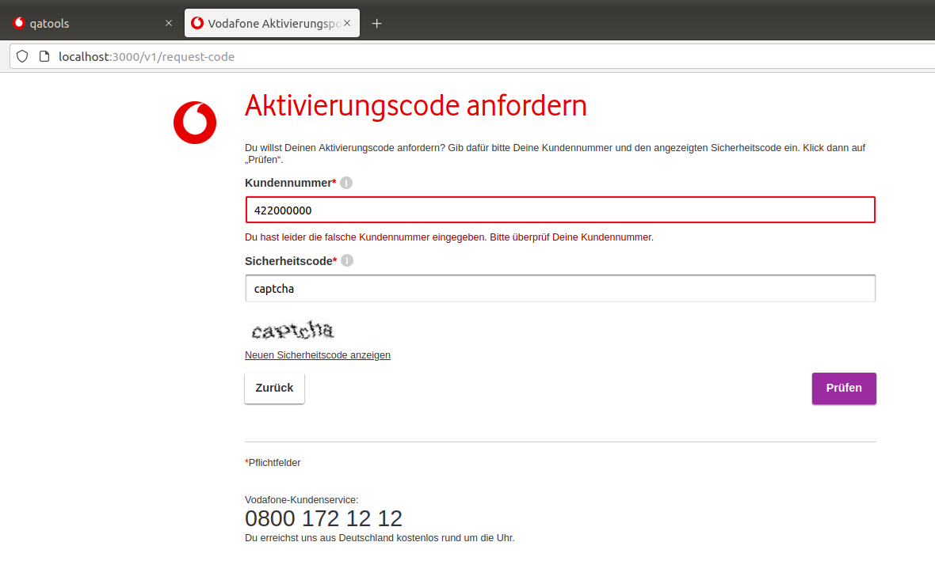

Case 3 : 400000000``` Invalid Json response (response is html)

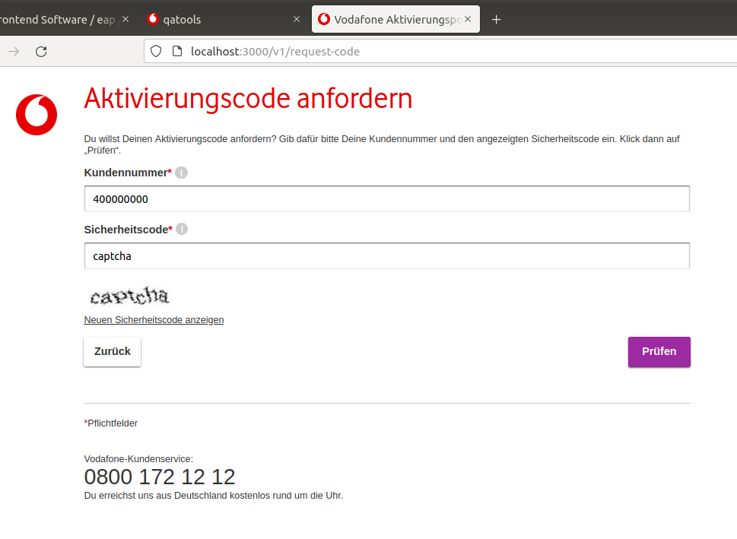

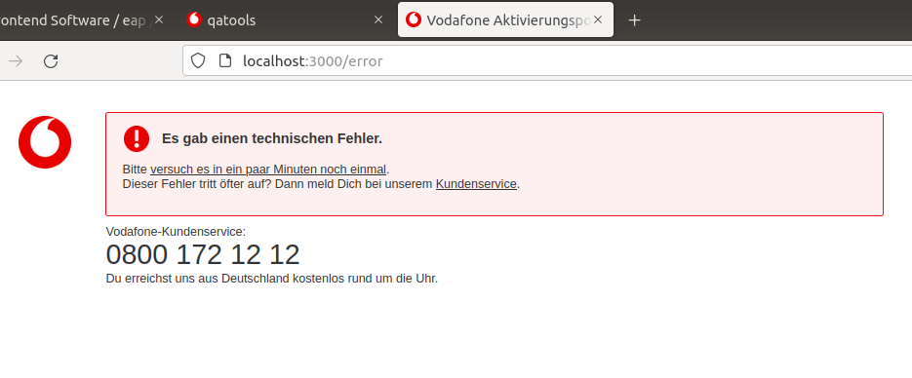
Case 4: 400000001``` CustomerNumber is valid but wrong type. So he cannot request a new activation code.

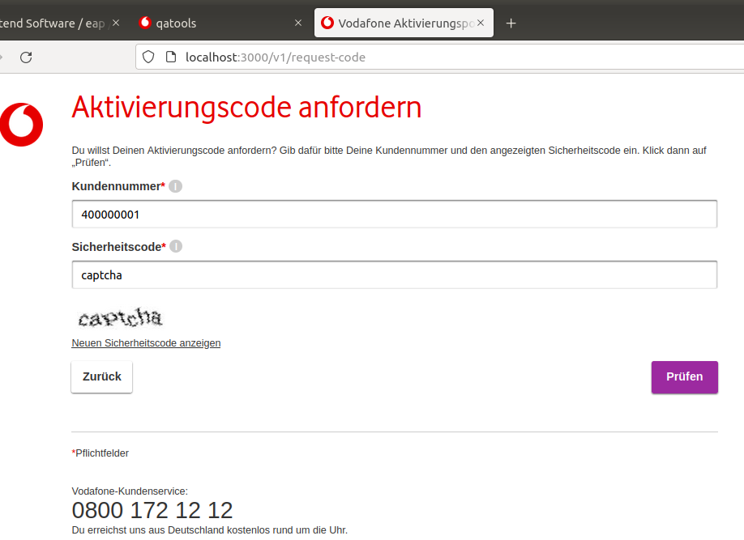

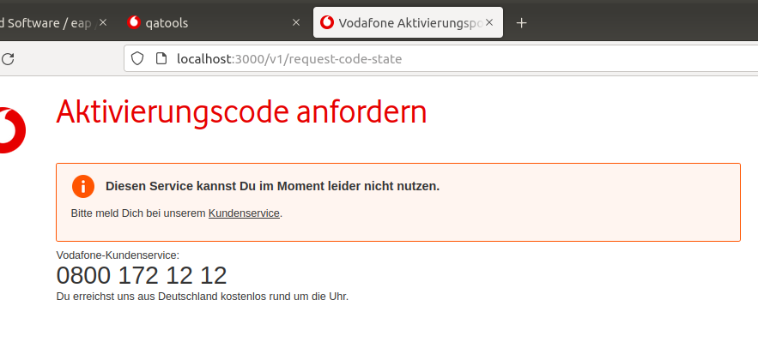

Case 5 : 400000002``` The Activation code was already requested before and is over 5 days old. So here he can request a new one.

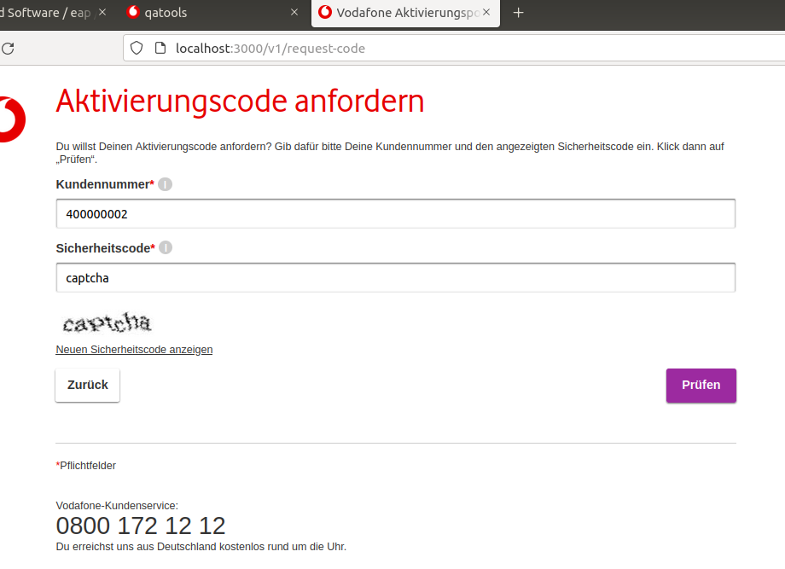

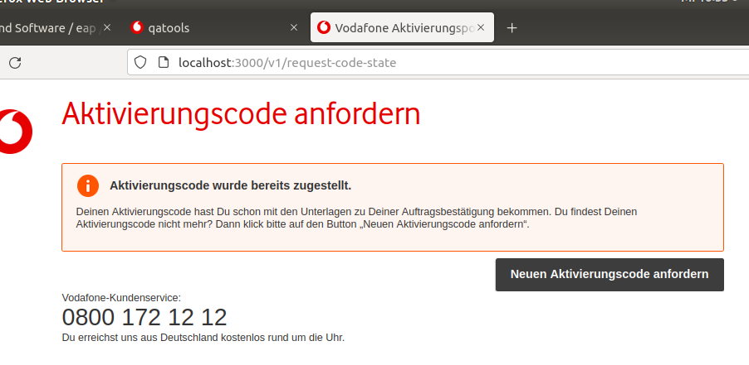

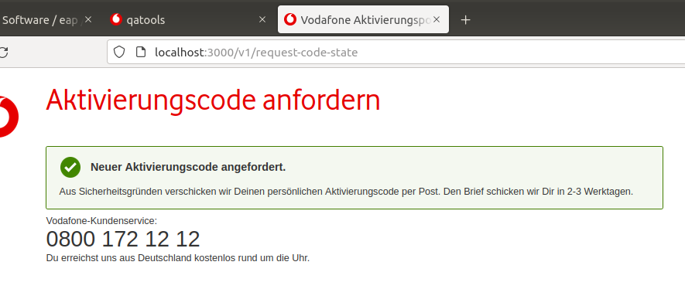

Case 6 : 400000003``` The activation code was already requested before and is under 5 days old. So here he have to wait.

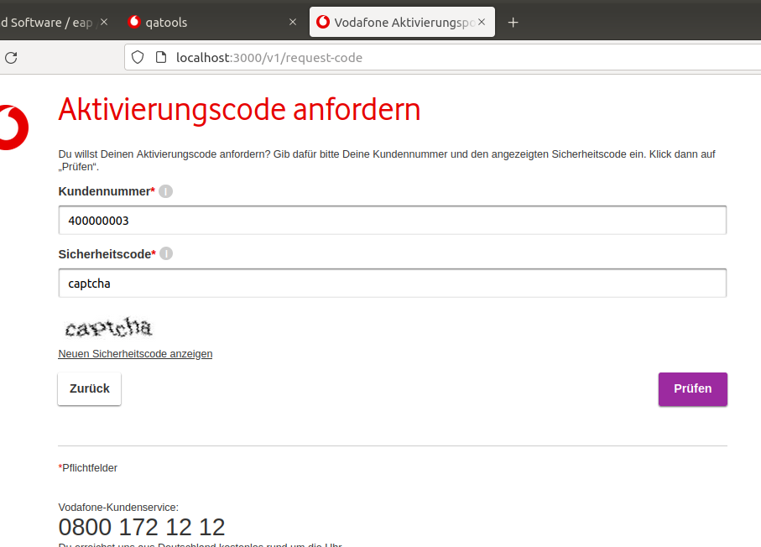

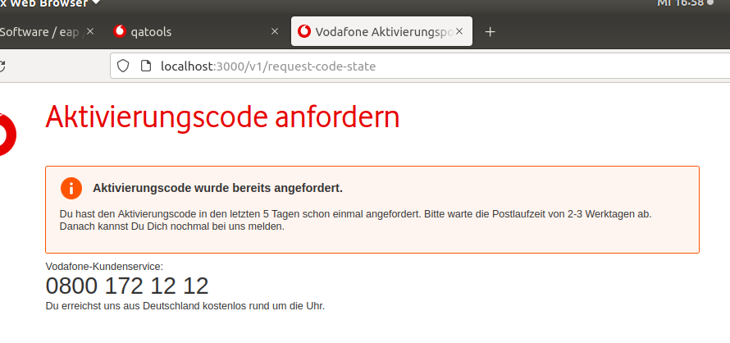

Case 7: 400000004``` The activation code was already requested several times. The limit is reached and he cannot request the activation code

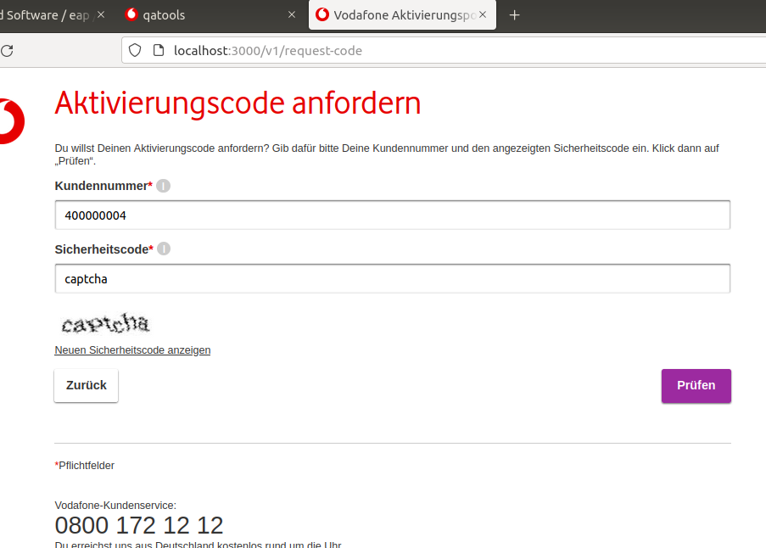

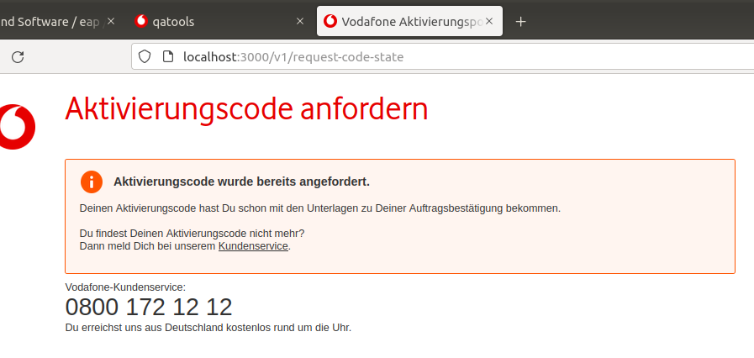

Case 8 : 500000000``` HTTP response status code is 500

